To order a new Terminal, Log in to your Stripe Account
1.Select
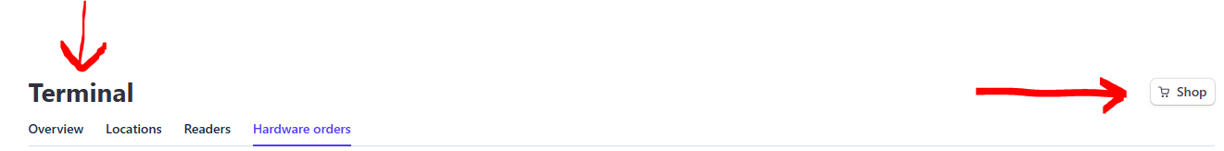

2.Click on
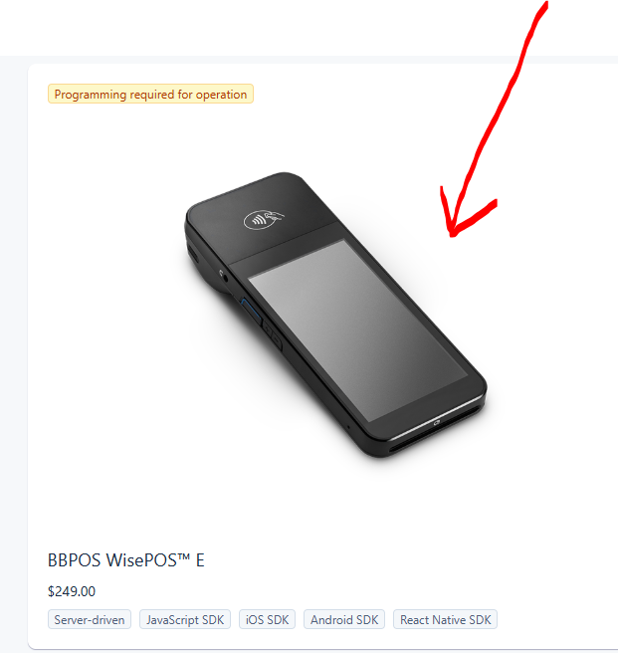
3.Make your purchase
