In Order to SINK Your GoSmartPOS System with your stripe account Production and Test Mode, you need to create keys in both your Real Environment and Testing SandBox environments in Stripe. When you get the keys follow the last step in pasting them into your GoSmart POS Backoffice for you business. These Keys are needed so that your POS System can be joined to your Stripe Account.

- Click on settings in Stripe
- Click on Developers

- Choose Manage API Keys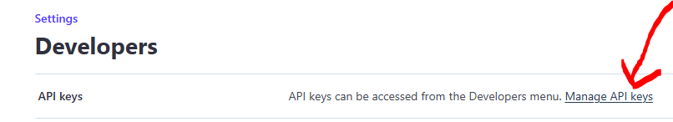

- Your Live key is for Real Payments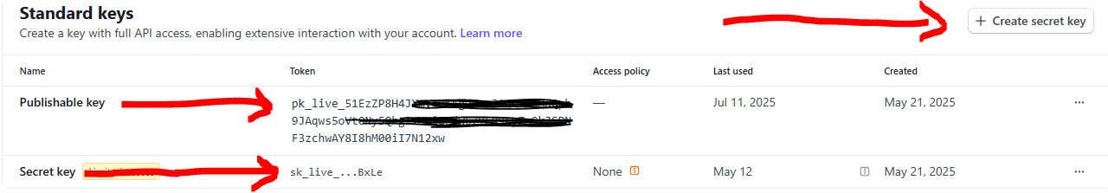

- Your Test Keys are for test transactions only
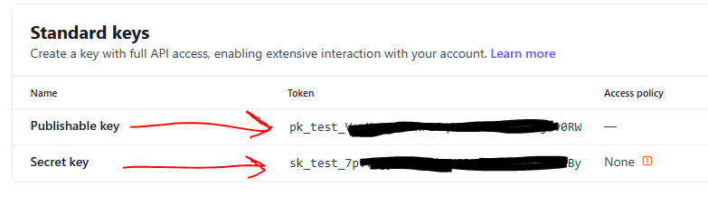

Log into your GoSmartPOSApp Backoffice – System Setup – Business. Paste your Live Keys where the red arrows are, Paste your Test keys where the yellow arrows are. Make sure the Publishable keys go into the correct box and the Seret keys go into the correct box. When finished click Update Business to save. The blue radio button that says “Stripe Card Testing Mode” when switched on like in the picture will force your system to be in test transaction mode, when switched off your system is in Live Transaction mode. This enables you to test transactions in Stripe without making real charges until you are ready.
