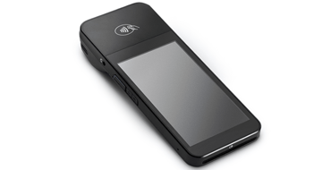To add a new Stripe Terminal device, you first need to create a Location in Stripe, then register/connect the reader.

Step 1: Open Stripe Terminal settings
Go to:
Stripe Terminal Dashboard

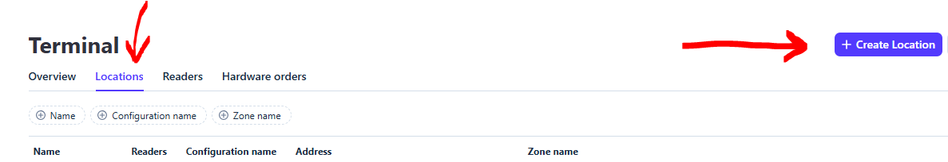

Step 2: Create a Location
Stripe Terminal devices must belong to a location.
Go to:
- Locations
- Click + New
Enter:
- Business/location name
- Address
- Time zone
Save it.

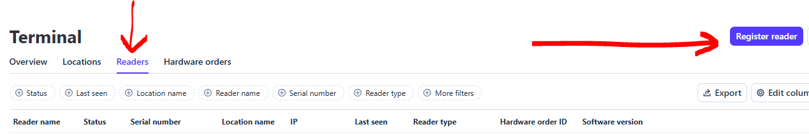

Step 3: Add/Register a Reader
Go to:
- Readers
- Click + Register reader
Stripe will ask which type:
- BBPOS WisePOS E

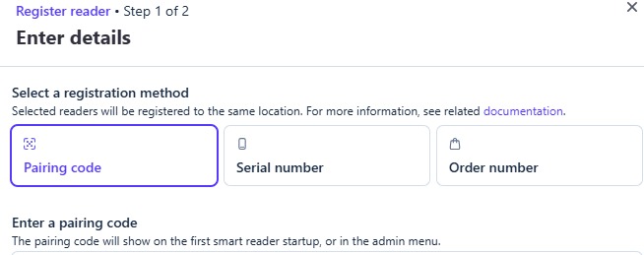

Step 4: Connect the Device
Internet-connected smart readers (WisePOS E)
- Power on device
- Connect Wi-Fi
- Reader shows a registration code
- Enter that code in Stripe Dashboard

