How to add your Stripe Terminal ID to your GoSmartPOS Setup

In Stripe Goto Terminal – Readers, then click on the row with your reader
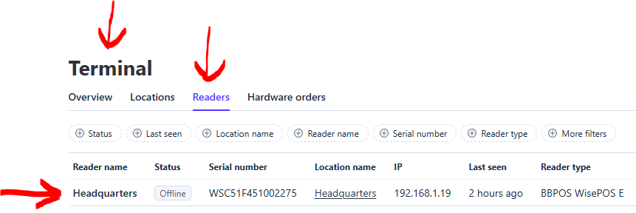

On the next screen you will see your Reader ID: Copy it
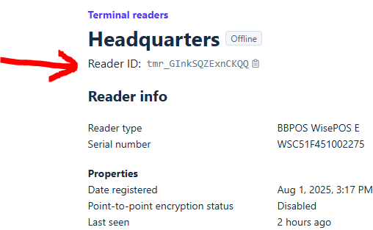

Log in to your Go Smart POS Backoffice and goto Card Terminal. To add this terminal to your POS, paste in the Reader ID you copied from above. The Terminal is linked to a Cash Drawer that you select. Now click Add Card Terminal.
