How to add gosmartposapp.com domain to your stripe account, so that payments can connect to your Stripe account.

- Click the Settings icon top right


2. Select Product settings - Payments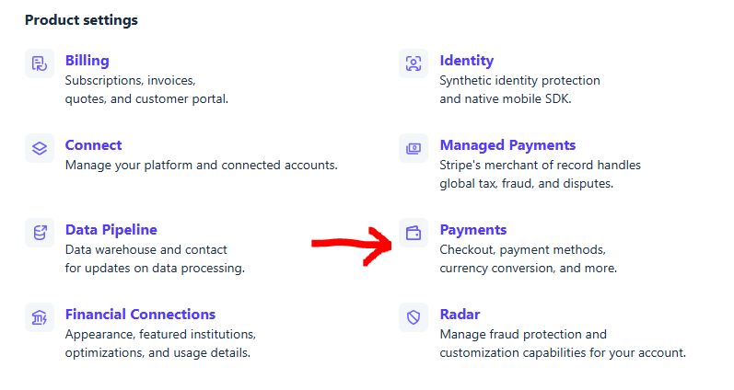

3. Select Payment method domains at the top
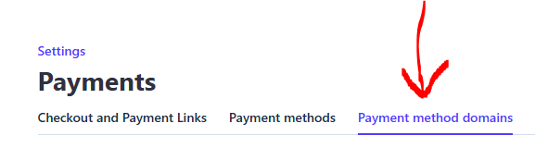

4. Select Add a new domain on the right


5. Type in gosmartposapp.com in the box, then click Save
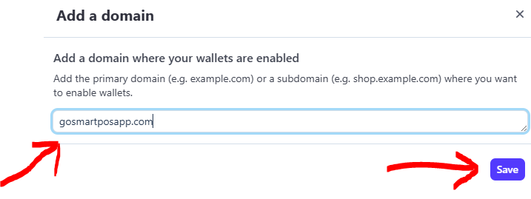

6. You should now see it in the List as Enabled


